Who we are  Home Education Partnership of Texas, Inc. is a partnership between home-schooling families and educational opportunities. Joanne E. Juren, B.A., M. Ed., is the principal and executive director, and she began HEP of Texas, Inc. to enhance home education opportunities.  The summer camps offered this year include:  - SAT Test Prep Courses  - Computer Science  - Culinary Arts  - Language Arts  - Math  - Science  - And more!  Contact Us  We are located on Fuqua Street on the east side of I-45 South, just north of the Sam Houston Tollway, at Exit 33:  11665 Fuqua St., Suite A-100  Houston, TX 77034  Phone: (281) 922 - 0472  Email: jjuren@hepbookstore.com  Web: www.heptx.com  HEP of Texas, Inc.  11665 Fuqua St., Suite A-100  Houston, TX 77034 |  |  | Summer 2015 Camp Schedule  Home Education Partnership  of Texas, Inc.  - “Knowledge through Freedom, the World through Home”

Table of Contents  Registration Information 1  Mother’s Day Out Camps 2  Art 2  Computer Science 3-4  Culinary Arts 4-5  Language Arts 6-8  SAT Writing 8  SAT Grammar 9  SAT Reading 9  Math 10  SAT Math 10  Quilting 11  Science 11  Speech 12  Study Skills 12  Adult Seminars 13 |  |  |  |  |  |  | Adult Seminars  Getting Ready for High School and College Seminar – If you have a student in 7th grade or above, then this class if for you. During this informative seminar, Joanne Juren will discuss many topics pertinent to students just entering high school. Topics include goal setting, course guidelines from 7th – 12th grade, the 4-year plan, high school transcript, extracurricular courses and activities, job co-ops, testing for high school and college, scholarships, and many more! Each parent will create a 4-year plan for his or her student(s). There will be plenty of time for questions and answers! With one paid adult, the student may attend free of charge. Reservations required. The Getting Ready for High School and College book and CD are available at the HEP Bookstore.  Instructor: Joanne Juren August 6 Cost: $35 9:00 AM – 1:00 PM  Jump Start Homeschooling Seminar – This free seminar will discuss the legalities of homeschooling, how to choose the right curriculum, and how to get started and organized. There will be a question and answer period. NO RESERVATIONS REQUIRED.  Instructor: Joanne Juren, B.A., M. Ed. Cost: FREE Session 1: August 1 10:00 AM – 11:30 AM Session 2: August 6 2:00 PM – 3:30 PM Session 3: August 8 10:00 AM – 11:30 AM Session 4: August 15 10:00 AM – 11:30 AM
 |  |  |  |  |  |  | 13
Speech  Speech Intensive (7th - 12th) – <Include speech intensive description here> <Include speech intensive description here><Include speech intensive description here><Include speech intensive description here><Include speech intensive description here><Include speech intensive description here><Include speech intensive description here>  Instructor: Joanne Juren Cost: $?? Session 1: June ?? 1:00 PM – 4:00 PM Session 2: July ?? 1:00 PM – 4:00 PM  Study Skills  How to Study Smarter, Not Harder! (7th - 12th) – Feeling disorganized? Don’t quite know how to tackle that load of homework? Want to learn how to study smarter, not harder? If so, this workshop is for you! Mrs. Juren will focus on 3 ideas that, if implemented, will turn you into a superstar student! First, we will examine the difference between an average student and a superstar student. Next, we will learn how to create a master schedule to organize our school work around our lives. Last, we will learn how to take notes with a learning log. This class is recommended for everyone who wants to move from mediocrity to excellence! Bring a spiral notebook, which is required for a demonstration activity, and a pen. Parents must pay the same fee as students attending this course. Reservations required. The How to Study Smarter, Not Harder! Book is available at HEP Bookstore.  Instructor: Joanne Juren Cost: $35 Session 1: June 11 1:00 PM – 4:00 PM Session 2: August 13 1:00 PM – 4:00 PM |  |  |  |  |  |  |  | Registration Information  The official HEP of Texas, Inc. registration form must be completely filled out, including the emergency information, health information, and parent release. No registration is considered official until payment for classes has been made. All summer courses must be paid for at the time of registration.  Registration is first come, first served. HEP of Texas, Inc. reserves the right to limit enrollment and to change times or dates if needed due to circumstances not under our control. Camps are open to home school, public school, and private school students.  Camps are grouped by subject. The instructors, dates, times, costs, and descriptions are listed for each camp, class, and workshop. All course descriptions listed are the intellectual property of HEP of Texas, Inc. and are protected by copyright law, 2015.  This schedule of camps also includes our adult seminars.
12 |  |  |  |  |  |  |  | 1
Mother’s Day Out Camps  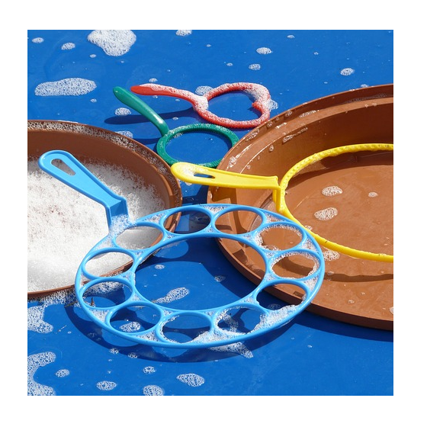  Medieval Camp (K - 3rd) – These day camps will run each Thursday from 9:00 AM – 2:30 PM on the days listed below. Students may sign up for one day or for all of them! This summer, students will go back in time to experience the Middle Ages! Through a variety of games, art activities, and learning experiences, students will learn about the knights, princesses, and adventures of the Medieval Age. Children should bring 1 snack for mid-morning and a sack lunch. Please do not send items that need to be heated. Each camp is $30, or sign up for all six for $160! Pre-registration is required as we accept no more than 20 students per week.  Instructor: Debra Long June 11, 18, 25  K – 3rd on Thursdays July 9, 16, 23  Cost: $30 per camp, $160 for all six 10:00 AM – 3:00 PM  Art  Art Intensive (5th - 12th) – Want to brush up on your painting skills or start from ground zero? Need to improve your drawing skills for those lab notebooks and English projects? Those who want to pursue their artistic interest in graphite to pastels, from watercolors to oils, join Beth Bishop for an art intensive to work on your own level, in your own media, at your own pace. All supplies are to be brought by the student. The supply list will be available online. There will be a lunch break, so bring a snack!  Instructor: Beth Bishop Cost: $150 Session 1: June 22 – 23 9:00 AM – 4:00 PM Session 2: July 13 – 14 9:00 AM – 4:00 PM |  |  |  |  |  |  |  |  | Quilting  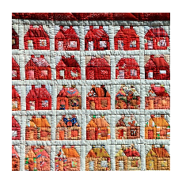  Quilting (5th - Adult) – Would you like to learn to quilt? Join us to create your own lap quilt! You will learn how to machine a simple quilt, form the “quilt sandwich”, actually quilt, and bind edges. Previous sewing experience is helpful but not required. Students must bring a working sewing machine and purchase their own fabric, but instructor will make suggestions. Please practice for homework so quilt may be completed by end of class.  Instructor: Paige McFall Cost: $160 Beginning Class: June 3 – July 15 1:00 PM – 2:30 PM Advanced Class: June 3 – July 15 2:30 PM – 4:00 PM  Science  Dissection Camp Intensive (7th - 12th) – Curious about worms? Eyeballs? Other yucky things? Are you yearning to learn how an animal looks inside and out? Then we have the camp for you. Our resident mad scientist will conduct two days of dissection fun. We provide all equipment and supplies. Bring a notebook and pen, and wear OLD clothes and closed toe shoes. This class may be a supplement a home taught biology course.  Instructor: Cheryl Red June 22 – 23 Cost: $160 (including all supplies!) 9:00 AM – 4:00 PM  Chemistry Camp Intensive (9th – 12th) – Fun and informative labs for the serious and not-so-serious chemistry student. This class is for those who want to put into practice the chemistry concepts learned in class. The labs to be completed include physical and chemical changes, acid / base equilibrium, determining density of liquids and solids, and the color explosion lab.  Instructor: Cheryl Red June 24 – 25 Cost: $160 (includes all supplies!) 9:00 AM – 4:00 PM
2 |  |  |  |  |  |  |  |  | 11
Math  Accelerated Math Three: Facts-Master (6-12 Years) – For students who understand addition and subtraction concepts but their skills need work. They will master all basic skills including borrowing, carrying, multiplication, division, rapid calculation, and memory training. Students who had trouble multiplying will be doing advanced math computations faster than a calculator! Accelerated Math Kits sold separately at the HEP Bookstore. Parent MUST attend class with students.  Instructor: Paige McFall June 2 – July 16 on Tues. / Thurs. Cost: $260 1:00 PM – 2:30 PM  Accelerated Math Five: Factor-Master – For teens and preteens who can multiply and divide. The course teaches mastery of all math operations: powers, factoring, and signed numbers. Students continue to increase their knowledge of fractions, rapid calculation skills, and memory training. Accelerated Math Kits sold separately at HEP Bookstore. Parent MUST attend class with student. No class July 3.  Instructor: Paige McFall June 2 – July 16 on Tues. / Thurs. Cost: $260 2:45 PM – 4:15 PM  SAT Math Workshop (10th – 12th) – The Math SAT is a test of arithmetic, algebra, and geometry. You need only a few simple principles. Mrs. Red, an experienced Math SAT teacher, will share these principles with you over this course. Test tips, calculator tips, and even pacing and relaxation tips will help you to raise your Math SAT score! Taking this course will give you plenty of time to hone your math skills before taking the SAT test. Students will need paper, a pencil, and a calculator.  Instructor: Cheryl Red Cost: $260 Session 1: June 22 – July 3 1:30 PM – 3:30 PM Session 2: July 13 – 24 10:00 AM – 12:00 PM 2 Day Intensive: July 27 – 28 9:00 AM – 4:00 PM |  |  |  |  |  |  |  |  | Computer Science  Intro to Game Programming (7th - 12th) – Video games may be fun to play, but they are a blast to create! In this class, students will learn the basics of game programming using Game Maker software. The software provides a drag and drop interface for creating games. We will cover the concepts of keyboard and mouse controls, adding sounds, keeping score, multiple levels, increasing challenges, and more! Students will need a USB drive.  Instructor: Melissa Juren June 29 – July 3 Cost: $195 1:00 PM – 4:00 PM  Intro to Digital Art (7th - 12th) – Today’s technology brings art into the digital age. Tablets have replaced canvases and offer virtually limitless creative options. In this class, students will learn the basics of digital art using a Bamboo Pad and the free image editor GIMP. We will cover the concepts of photo enhancement, drawing techniques, and graphic design. Students will need a Wacom Bamboo Pad and a USB drive.  Instructor: Melissa Juren June 22 – 26 Cost: $195 1:00 PM – 4:00 PM  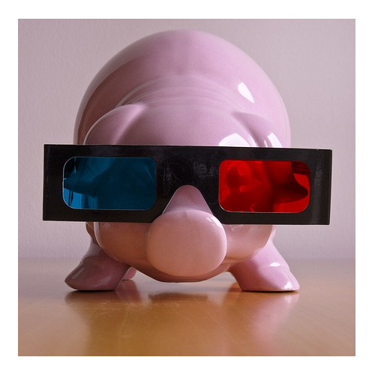  Intro to Animation (7th - 12th) – Ever wanted to make your own 3D movie? Now is the time to learn how! In this class, students will learn the basics of creating 3D animation using Muvizu software. We will cover concepts such as creating and customizing characters, manipulating virtual lights and sound effects, and handling lip-synching. Students will need a USB drive.  Instructor: Melissa Juren June 22 – 26 Cost: $195 9:00 AM – 12:00 PM
10 |  |  |  |  |  |  |  |  | 3
Robotics (5th - 8th) – Are you ready for robotics? Expand your skills with building, programming, and testing your robotic creations! Learn and practice science and engineering skills with LEGO Mindstorms kits and other materials. Learn how to use sensors to program your robot. Class is limited to 10 students.  Instructor: Melissa Juren June 29 – July 3 Cost: $175 10:00 AM – 12:00 PM  Elementary Computer Intensive (3rd - 5th) – Are Give your child a head start by starting computer classes early. From keyboarding to Microsoft basics, your child will learn to create and edit a variety of MS Office documents. Students will work with basic Excel spreadsheets, build a simple PowerPoint presentation, and experiment with other fun graphic applications. Students will need a USB drive and access to a computer at home.  Instructor: Melissa Juren July 7 – 8 Cost: $195 9:00 AM – 4:00 PM  Culinary Arts  Intro to Culinary Arts (7th - 12th) – Sugar and spice and lots of things nice, put it in a bowl for dinner tonight! This course is an introduction to the Art of Culinary and its history with the opportunity to taste your experience. There will be an iron chef competition at the end of the week. Class size is limited. Students will each receive a chef’s hat. Supply list available online.  Instructor: Executive Chef Karen Freeman, CCP/IACP July 6 – 10 Cost: $175 (includes food and hat) 1:30 PM – 3:30 PM |  |  |  |  |  |  |  |  | Current SAT Grammar Workshop (10th - 12th) – Nouns, verbs, and gerunds…oh my! Learn the top 10 Rules for Grammar Success on the SAT test and improve your score! The week long, intensive grammar review focuses on types of SAT grammar questions. Once you learn how the test phrases the questions and how to find the errors, you will gain Grammar Confidence. This course may be taken independently of or concurrently with the SAT Writing Workshop. Note: This class is based on the current SAT. The new SAT begins in March 2016.  Instructor: Joanne Juren Cost: $99 Session 1: June 8 – 12 3:00 PM – 4:00 PM Session 2: July 13 – 17 9:00 AM – 10:00 AM  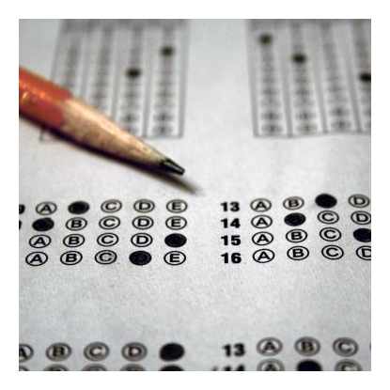  Current SAT Reading Workshop (10th - 12th) – This workshop outlines in 10 steps the approach to the Critical Reading portion of the SAT and its 2 types of questions: sentence completion and passage-based questions. This workshop helps students develop and refine skills that, once mastered, will result in higher scores and enhanced knowledge for students just beginning on the SAT journey. Bring a favorite book, paper, pen, pencil, and highlighter. Note: This class is based on the current SAT. The new SAT begins in March 2016.  Instructor: Karen Freeman Cost: $160 Session 1: June 8 – 12 10:30AM – 12:00 PM Session 2: July 13 – 17 1:30 PM – 3:00 PM Session 3: July 20 – 24 10:30 AM – 12:00 PM
4 |  |  |  |  |  |  |  |  | 9
Writing Skills for Elementary Students (4th - 5th) – In this exciting elementary camp, students will learn to fall in love with writing though a variety of fun, hands-on creative activities. Students will practice several types of writing and discover writing can be fun! Bring a notebook and a pencil.  Instructor: Melissa Juren July 6 – 10 Cost: $160 10:00 AM – 12:00 PM  Writing Workshop (6th - 12th) – <Insert writing workshop description here> Tiffany Tiggues is a Texas A&M freshman, former HEP graduate, and an English major. During high school, she worked as a proofreader for a published author, was an HSLDA Poetry Contest Finalist, and authored her first book, The Island of Eden.  Instructor: Tiffany Tigges Cost: $160 July 6 – 10 1:30 PM – 3:00 PM  Current SAT Writing Workshop (10th - 12th) – The SAT essay must establish a “clear point of view,” include “evidence to support your position,” and have a “logical structure.” This course teaches students how to address the writing prompt, brainstorm ideas, and write a high-scoring essay. Students will write at least one SAT essay each day in class and receive prompts to practice at home. Students will focus on writing the four-paragraph essay. Note: This class is based on the current SAT. The new SAT begins in March 2016.  Instructor: Joanne Juren Cost: $160 Session 1: June 8 – 12 1:30 PM – 3:00 PM Session 2: July 13 – 17 10:00 AM – 11:30 AM 2 Day Intensive: August 5 – 6 9:00 AM – 4:00 PM |  |  |  |  |  |  |  |  | Culinary Fun for Kids (4th - 6th) – Cooking is an excellent way for children to learn responsibility and valuable skills. Join Chef Karen for a week of fun creating delicious goodies for the holidays and entertaining. Students will learn to follow directions, practice safe food handling techniques, and create delicious and fun recipes. We will provide all of the food and a chef’s hat that you may keep. Supply list available online.  Instructor: Executive Chef Karen Freeman, CCP/IACP July 6 – 10 Cost: $175 (includes food and hat) 10:30 AM – 12:00 PM  Culinary Intensive (9th - Adult) – In addition to the traditional culinary class, European Classic Cuisine Chef Karen Freeman is offering a series of 2 day culinary intensive classes focusing on general, Asian, and Italian cuisine. A Certified Culinary Professional and member of the International Association of Culinary Professionals, Karen Freeman will offer a combination of instruction, observation, and hands-on culinary techniques that will leave you secure in the fact that your dinner menu will be well-received, impressive, and delicious! Class requires a basic knife and cooking skills. Eat a light lunch before coming. Equipment list will be available online. Class size limited to 20.  Instructor: Executive Chef Karen Freeman, CCP/IACP Cost: $175 (includes food and hat) 2 Day Basic Session: June 29 –30 11:00 AM – 3:00 PM 2 Day Asian Session: July 1 – 2 11:00 AM – 3:00 PM 2 Day Italian Session: July 27 – 28 11:00 AM – 3:00 PM
8 |  |  |  |  |  |  |  |  | 5
Language Arts  No Be Verbs and Other Grammar Rules (7th - 12th) – If you are confused about “be” verbs, this is the course for you! During this workshop, students will become stronger writers by exploring grammar myths and facts. Students will learn to write actively without the form of “to be.” Students will identify fragments, comma splices, other serious writing errors and learn to avoid them. Students will work on elevating word choices and language use.  Instructor: Karen Freeman Cost: $160 Session 1: June 22 – 26 1:30 PM – 3:30 PM Session 2: July 13 – 17 10:00 AM – 12:00 PM  Middle School Writing Workshop (6th - 8th) – During middle school, it is important for students to develop strong writing skills. By understanding the writing process, student will better understand how to do writing assignments. During this workshop, students will focus on the paragraph format and write different types of paragraphs including descriptive, narrative, comparison, and literary analysis. This course is a must before students attempt the five paragraph essay and high school English.  Instructor: Joanne Juren June 8 – 12 Cost: $160 10:00 – 11:30 AM  Creative Writing (6th - 8th) – Stories are everywhere. One only has to learn how to “see” them. Let your imagination soar with a class in Creative Writing. Students will learn the principles of writing and storytelling and the different types of creative writing including short stories and poetry.  Instructor: Melissa Juren July 6 – 10 Cost: $160 1:30 PM – 3:30 PM |  |  |  |  |  |  |  |  | Five Paragraph Essay Writing Workshop (8th – 12th) – This four day workshop will teach the basics of five-paragraph essay writing. Students will learn the basic structure of the essay through a visual drawing. They will practice each part of the essay and write one essay. Students will learn how to expand this “skeleton” to a longer research paper. This easy and interesting presentation will help even the “grumpiest” writer learn that writing can be easily mastered when given the proper tools! Mastery of the five-paragraph essay will help students earn success in both high school and college. Absolutely no one younger than 8th grade may attend this accelerated presentation. This course is not recommended for students who struggle with English or who do not have mastery of basic paragraph writing. The book Writing with the Masters is required for the workshop and may be purchased at the HEP Bookstore. On the first day of class, students should also bring 3 juvenile library books on one of the 7 planets in the solar system (excluding Earth and Pluto). Class is limited to 15 students each session. Students should sign up for one session. New students getting ready to attend HEP’s high school classes are recommended to take this course.  Instructor: Joanne Juren Cost: $160 Session 1: June 8 – 11 10:00 AM – 12:00 PM Session 2: July 13 – 16 1:00 PM – 3:00 PM 2 Day Intensive: August 3 – 4 9:00 AM – 4:00 PM  Research Writing Class (10th – 12th) – Research papers can be daunting unless you know where to begin. In this class, the approach is broken down into simple, easy-to-follow steps that remove the stress that comes with large writing projects. Students should understand the MLA format and five-paragraph essays. The book Writing with the Masters is required.  Instructor: Karen Freeman Cost: $160 Session 1: June 8 – 12 1:30 PM – 3:30 PM Session 2: June 22 – 26 10:30 AM – 12:30 PM Session 3: July 20 – 24 1:30 PM – 3:30 PM
6 |  |  |  |  |  |  |  |  | 7

