**OCTOBER ……….Right around the corner☺**

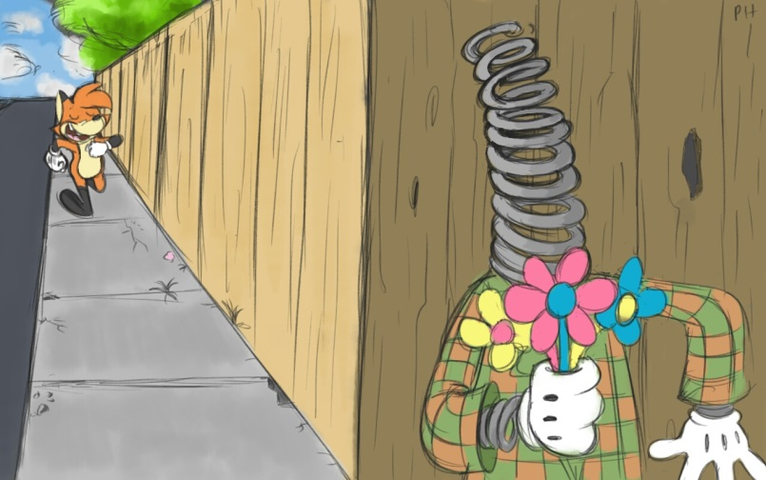

**HEP TX Blast September 30, 2020**

Here’s to our fall weather!! As we pull out jackets (we are in Texas), decorate for fall, and smell the pumpkin lattes, cookies, cakes, etc. we hope that it will bring about positive changes for the end of 2020. Our time together has continued to bless each of us, and although crazy at times, it moves quicker than expected! Some of our classes arrived at 6 weeks this week! We continue….

***Going with the flow of life (His flow).***

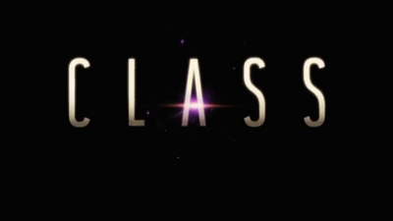

**As a reminder the following changes have been made to account for our Beta interruption.**

Monday Classical School – Make up on Monday, Nov. 30th

Mrs. M. Juren will do Zoom make-ups for her Tuesday classes this Friday (9/25).

Tuesday classes for Mrs. Wales, Mrs. Coker-Garcia, and Mrs. Rothberg - Make up on Tuesday, Dec. 1.

Wednesday Classes for Middle School Speech, Middle School Art, Middle School Computer Science, PreK3 & 4 - Make up Dec. 2.

**Calling ALL MIDDLE SCHOOLERS (6th-8th)**

**Join us for Games & Pizza -- FRIDAY**

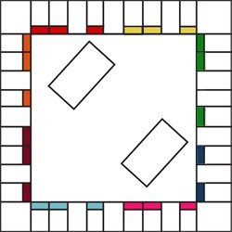

It is YOUR turn to have some fun getting to know one another, THIS FRIDAY, October 2nd at noon join us as we order pizza and play some games. I realize it is not a “huge” activity just yet, but we would like for you all to have a chance to get to know you before moving to a bigger space. We will play some “get to know you games” as well as some others. Come join us for some fun! SIGN UP with the ladies at the front desk. Friday, Oct. 2nd from 12 p.m. to 2 p.m. $5 per student for pizza, drinks, and snacks. WE CAN’T WAIT TO SEE YOU!



Have you ever dreamed of traveling to another part of the world? Have you imagined yourself experiencing another culture, enjoying different food, learning about history in a new manner?

Come join HEP as we travel to **SCOTLAND & IRELAND**

March 5-14, 2020

Sign up quickly if you want to save $150!!! Tour ID Juren: 8317

PowerPoint link:

<https://www.teacherease.com/common/DigitalLockerGetGeneralFile.aspx?DLGFID=69763&State=TX&DownloadRefID=81baa4f6-8a03-4a47-9bfa-9b648bc5ce06>



Reminder: Graduation Meeting

HEP on October 8th at 6:30 p.m.

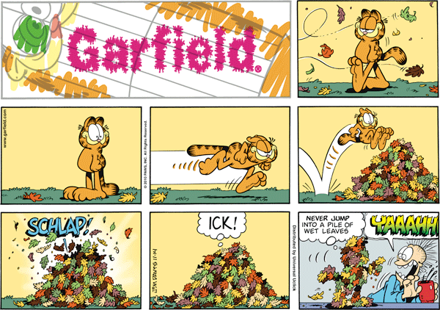

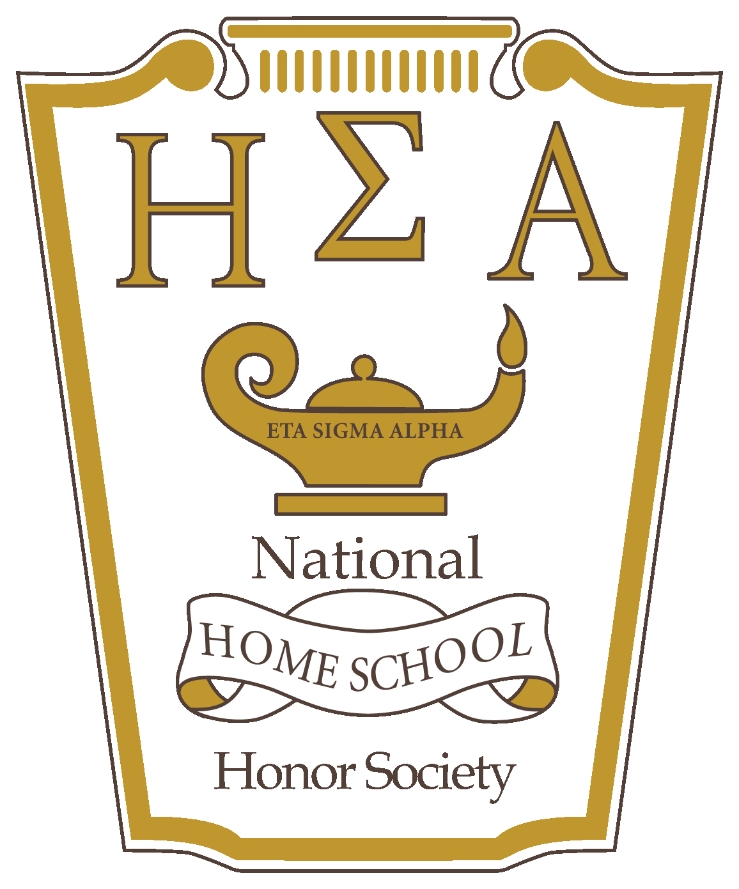

ESA Chapter

We encourage you to fill out an application for ESA and join us on this exciting journey through the fall and spring semester! More information can be found at esaalphachapter.com

**Save the Date!!!**

Homecoming & Santa C:\Program Files (x86)\Microsoft Office\MEDIA\CAGCAT10\j0183290.wmf

**Friday, Dec. 4, 2020**

Pre-K through 7th Grade 8th Grade – 12th Grade

Santa, Snacks & Homecoming Court, Santa, &

Christmas Crafts Christmas Themed Dance

3:00-5:00 p.m. 7:00-10:30 p.m.

For the adults…. ☺





**FUTURE DATES**

Prom - April 22, 2021 - Golfcrest Country Club

Graduation - May 15, 2021 - Sagemont Church or Hope Lutheran