Pre-K 3 and 4 Schedule
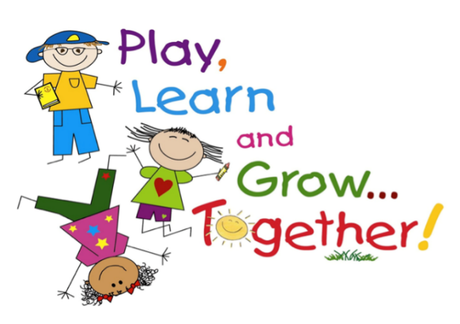
Under the direction of a great team of teachers using a Montessori-style approach to learning, students will explore new ideas, experience hands on learning, and learn to work with others.
The children will spend most of their time playing and working with materials or other children. They will have access to various activities throughout the day. From assorted building blocks and other construction materials; props for pretend play; picture books; paints and other art materials; and table toys such as matching games, pegboards, and puzzles, the children will have loads of fun playing and learning in a set of rooms designed just for them!
Our young learners will learn numbers and the alphabet in the context of their everyday experiences. Children will develop hand strength and practice fine motor skills with activities designed around cutting, threading, painting, transporting small parts, and more. Students will learn letters and sounds through purposeful play, games, crafts, and multi-sensory activities. Students will also enjoy learning Spanish. Simple words, phrases, and cultural ideas will be presented using a variety of fun activities.
The children will work on projects and have long periods of time to play and explore each day. All will enjoy exploring and exercising in our Sensory Zone. With bright colors and stimulating activities such as our new sensory path, exercise equipment, games, and toys, the children will love playing in the Sensory Zone.
After play time, teachers will read books to children individually or in group story time. Each child will have fun playing with their friends and teachers.
Class will be limited to 8-10 students ages 3-4. Children must be potty-trained. There will be a short nap time provided
Students should bring a sack lunch, but no foods to heat up. Students should also bring a change of clothes in case of an accident.
Dates: Wednesdays – Fall 8/31-11/16/22 and Spring 1/18-4/12/23
Time: 9:15-2:45 pm (no after class babysitting provided)
Cost: $1500
Lead Teacher: Leigh Ann Whitman
Spanish Teacher: Alejandra Guerra-Moxey
Art/Create Teacher: Debby Jasinski

