Pre-K4 & K5 Schedule
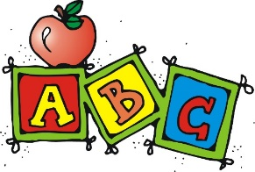
Under the direction of a great team of teachers using a Montessori-style approach to learning, students will explore new ideas, experience hands on learning, and learn to work with others.
The focus of the Pre-K4 and K5 Classical Program will be on reading readiness, early reading, math readiness, early math with games, memory work, science and social studies units, Spanish, music, and art. Taught by an Elementary Certified teacher, students will explore new ideas, experience hands on learning, and learn to work with others.
The students will enjoy exploring and exercising in our new Sensory Zone. With bright colors and stimulating activities such as our new sensory path, exercise equipment, games, and toys, the children will love playing in the new Sensory Zone.
HEP TX Goals:
- Expand the child’s ability to learn about (and from) the world, organize information, and solve problems. This increases his feelings of self-worth and confidence, his ability to work with others, and his interest in challenging tasks.

- Provide a combination of formal (teacher-initiated) and informal (child-initiated) activities. Investigations and projects allow your child to work both on her own and in small groups.

- Activities will feature play-based, hands-on learning in small groups.

- Foster a love of books, reading, and writing.
Class will be limited to 8-10 students ages 4-5.
Students should bring a sack lunch, but no foods to heat up. Students should also bring a change of clothes in case of an accident.
Parents will be expected to cover the areas of Phonics/Reading, handwriting, and math at home.
Dates: Wednesday - 9/4-11/20/19 and 1/22-4/15/20
Time: 9:15-2:45 pm
Cost: $1500
Teachers: TBA, Team Leader
Api Wales, Spanish Instruction
Debby Jasinski, Art/Movement Teacher

