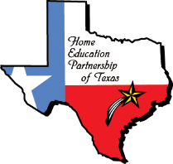
Classical School Schedule
Grades 1-5

What is Classical Education?
Classical Education returns to the time-honored educational theory of the past. The classical method was the only educational theory in practice in Western Civilization for over two millennia. Beginning in Classical Greece and Rome, and continuing through the Puritan and Colonial eras of our nation, children that were fortunate enough to receive an education received a classical one. Classical Education produced Archimedes, St. Paul, St. Patrick and Columba, Dante, Leonardo da Vinci, Galileo, Sir Isaac Newton, Christopher Columbus, Shakespeare, and our own great George Washington, Thomas Jefferson, and John Adams. These giants of their times are only the tip of the iceberg of the great philosophers, scientists, theologians, writers and artists that lived and worked through the 18th century. They lived up to their potential, and each in their own way impacted the course of human history because their potential was unlocked in part by Classical Education, which prepared them to grapple with the problems of their day.
The core of Classical Education is the trivium, which simply put is a teaching model that seeks to tailor the curriculum subject matter to a child’s cognitive development. The trivium emphasizes concrete thinking and memorization of the facts of the subjects in grade school; analytical thinking and understanding of the subjects in middle school; and abstract thinking and articulation of the subjects in high school. Subjects unique to Classical Education which help accomplish the goals of the trivium are Grammar, the science of language usage; Logic, the science of right thinking; and Rhetoric, the science of verbal and written expression. Classical Christian Education is further characterized by a rich exposure to the history, art, and culture of Western Civilization, including its languages (Latin and Greek), its philosophy and literature (the Great Books of Western Civilization and the Christian tradition), and the development of a Biblical worldview.

Why Return to Classical Education?
The combination of the progression of learning from facts to understanding to expression (the stages of the trivium) and the additional classical subjects, work together to give children the tools to think for themselves and to be independent, life-long learners. That is the primary goal of Classical Education. It is to equip educated men and women able to approach previously unknown subject matter, problems, or life situations; and using the tools of learning which have been practiced and refined and internalized in school; to grasp the subject or problem, analyze it according to the standard of truth, and understand and do something about it. Classical Education therefore trains children for success in any field, whether it be marriage and family life, work dealing with society and individuals, business, or arts and the humanities. Furthermore, Classical Education has proven its effectiveness in training for scientific excellence, which depends on the arts of fact-finding, analyzing, adherence to truth, and the problem-solving skills of which Classical Education specializes. Secondarily, it works: children taught by this method routinely exhibit academic proficiency.
In classical education, history lies at the center of the curriculum. The chronological study of history allows even small children to learn about the past in an orderly way. We use the Story of the World four-book series as our history program for third through seventh grades. Students enrolled in 2021-22 will study the Ancient Times, and over the next three years will study the Medieval Times, Early Modern Times, and Modern Times. Each age group will enjoy age appropriate activities and learning experiences. The purpose of our program is to give the child a love for history, create a basic understanding of major cultures, and an idea of the chronological order of historical events. Our 8-12th grade program is a strong Classical/College Preparatory program with a heavy emphasis on history, writing, and literary analysis in the Journey through Time courses.
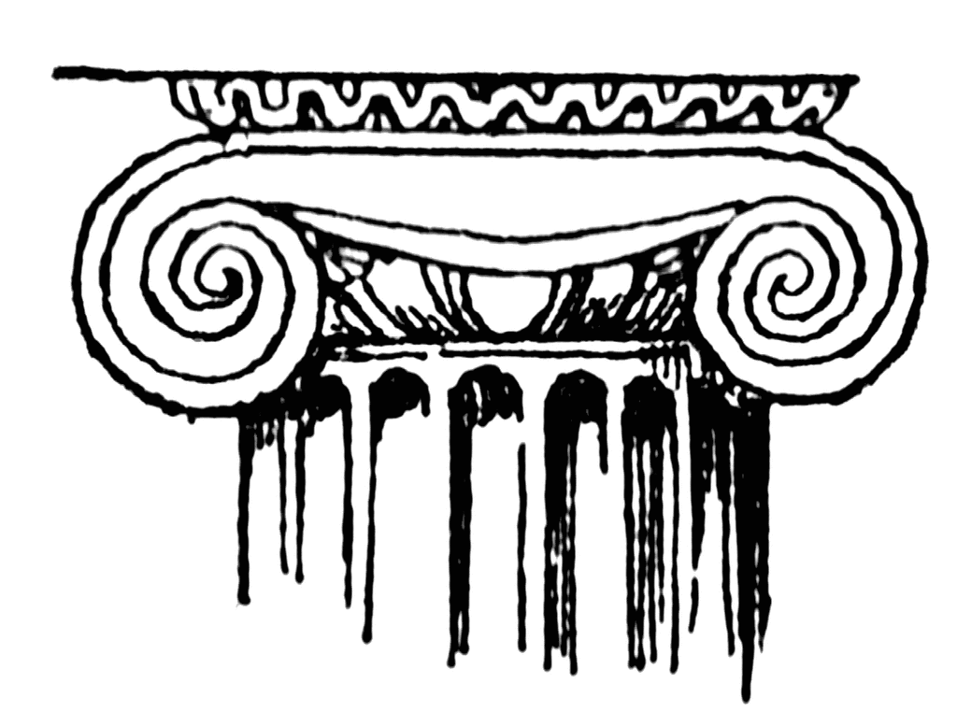

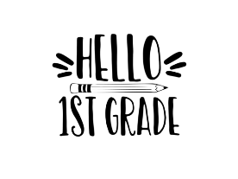
Grades 1-2
On Mondays, students will explore Spanish, Song School Latin, science, and math. For part of the day students will enjoy CREATIVITY (21 Tools, creative movement, music, sensory path, and other activities that will help focus, attention, concentration, and attitude) with Debby Jasinski. Every other week, students will also learn about COMPUTER SCIENCE (basic coding, Code & Go Robot Mouse activity, and some simple digital art) in the computer lab with Melissa Juren.
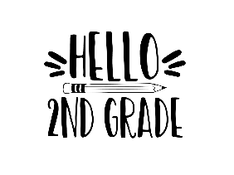
On Thursdays, students will explore language arts, history, music, Spanish, and art.
Under the direction of a great team of teachers using a Montessori-style approach to learning, students will explore new ideas, experience hands on learning, and learn to work with others. Students should bring a sack lunch, but no foods to heat up.
Teachers: Leigh Ann Whitman (Lead Teacher); Debby Jasinski (Create/Art); Melissa Juren (Computer Science); and Alejandra Guerra-Moxey (Spanish)
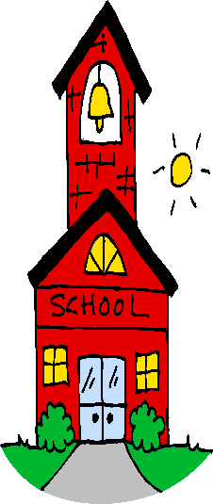
Grades 3-5

Under the direction of a great team of teachers using a Montessori-style approach to learning, students will explore new ideas, experience hands-on learning, and learn to work with others. Students should bring a sack lunch, but no foods to heat up.

Grades 3-5 cover Spanish, Math Enrichment*, Creativity, Music, and Computer Science on Mondays. Grades 3-5 cover Science, Language Arts, History, and Art on Thursdays.
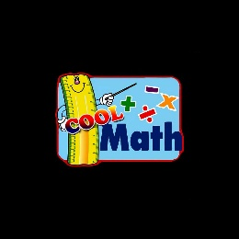

*Math Enrichment covers reinforcement of basic skills at the child’s specific level of ability, as well as math games, mind math, and overall math stimulation. One of our chief purposes is to instill a love for math and for students to understand its usefulness.

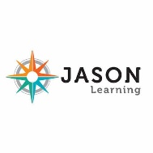
Our Science classes use the award-winning Jason Science Program. During the fall semester, students will explore “The Monterey Bay Marine Sanctuary.” Using hands-on activities, students will dive into the Monterey Bay Marine Sanctuary off the cost of Monterey, California, to explore many of the region’s fascinating ecosystems. Science topics include ocean circulation, watersheds, kelp forest ecosystems, predator-prey relationships, population dynamics and various careers.
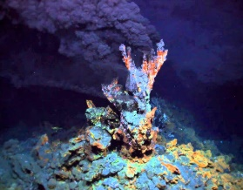
The spring semester focuses on “Life at the Extremes.” Students will travel deep into the Mid-Atlantic Ridge to explore the unique "Lost City" hydrothermal vents. Science topics include plate tectonics, rocks and minerals, chemical reactions, pH, buoyancy and much more.

Students will be taught the importance of recording their observations and conclusions from each activity using the scientific method. A science notebook will be provided for this. Homework will include watching videos and reading certain material and then recording what they have learned in a separate notebook. No textbook required.

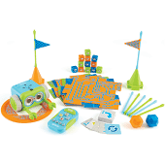
Botley the Robot (Computer Science): Grades 4 and 5 will enjoy “computer programming” with Botley, the Robot. This activity is a BIG HIT with the students. They will continue learning more with Botley by adding Challenges! Students will work with other engineering activities learning about programming while having a great time.

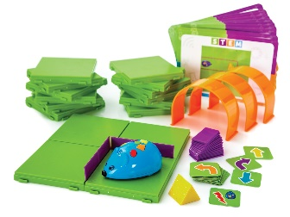
Code & Go Robot Mouse (Computer Science): Grade 3 will learn about computer science and coding using our Code & Go Robot Mouse activity! Students will get to design and create their very own maze for our Robot Mouse. Once the maze is complete, students will use coding cards and their problem-solving skills to teach the mouse to navigate the entire maze to find its cheese! They can redesign the maze multiple times to create and solve different challenges, all while learning to code without a screen. Students will take turns redesigning the maze and will solve the maze together using the coding cards along with the buttons on the Robot Mouse itself. They can even add some funny sounds and random actions for our Robot Mouse to perform to add a bit of fun!

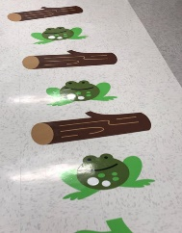
Sensory Path: Creative movement, exercise, games, and other neurodevelopmental activities make the “sensory path” and “exercise” room a blast! Students enjoy games, exercise, the 21 Tools, and other fun games and movement activities. Studies have shown that recess and movement help with focus, attention, attitude, and enjoyment. Students also use jump ropes, ribbons, scooters, hula-hoops, balance equipment, and eye/hand coordination games, to develop physical strength, balance, and coordination.

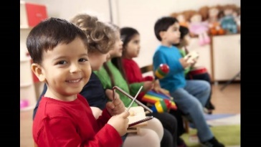
Music Listening and Movement: To complement our history program, Story of the World, the Ancient Times, the music class will explore music history of past ages. Students will study and listen to important composers of the day. They will develop and use listening maps as they experience the music. Students will explore the music by singing and dancing. Taught by an experienced music and choir teacher, students will have fun while discovering their musical talents.

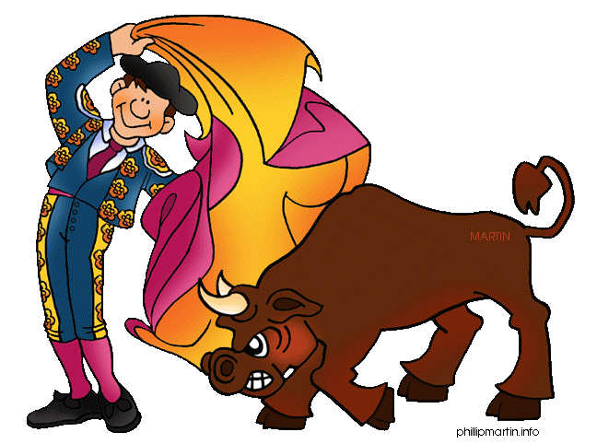
Spanish – Using the Total Physical Response (TPR) teaching method, Spanish classes incorporate music, physical activities, visuals, cards, games, and lively competition to make language learning fun and meaningful. Students acquire a second language in the same non-threatening manner as they did their first language: through exposure, observation, and interaction.

Teachers: Mary Sweeney (Spanish), Sue Rothberg (Science), TBA (Math 4 and 5), Debby Jasinski (Create/Art), Melissa Juren (Computer Science/Math 3), Amy Titus (Music), Mandy McDonald (Language Arts) and Tiffany Henry (History).

At Home: For grades 3-5, parents must cover the areas of Phonics/Reading, handwriting, spelling, and math at home. For those students who come only on Mondays, parents will need to cover science, language arts, and history at home.

Classical School Grades 1-5

Dates: Mondays – 8/23-11/15/21 and 1/17-4/11/22 (Off for Labor Day 9/6/21)
Thursdays – 9/2-11/18/21 and 1/20-4/14/22
Time: 9:15-3:15 pm
Cost: Mondays: $1800
Thursdays: $1800
Both Days: $2800 (2 day discount included)

